VSCODE Features

## Built-in Features

Some of the built in features that Visual Studio Code has to offer can be extremely helpful in creating an application faster. These tools vary from adding command prompts and PowerShell to shortcuts to make your code look much nicer.

The first tool or feature we are going to go over is the terminal feature that can be used to run, download, and install anything. These terminals all act like they would if they were outside the application.

First thing you will need to do is to click ***Terminal*** in the top left corner. The button is highlighted in the image below with the color orange. The second step is to select ***New Terminal*** which is highlighted with the color blue. (Shortcut: Ctrl+Shift+`)

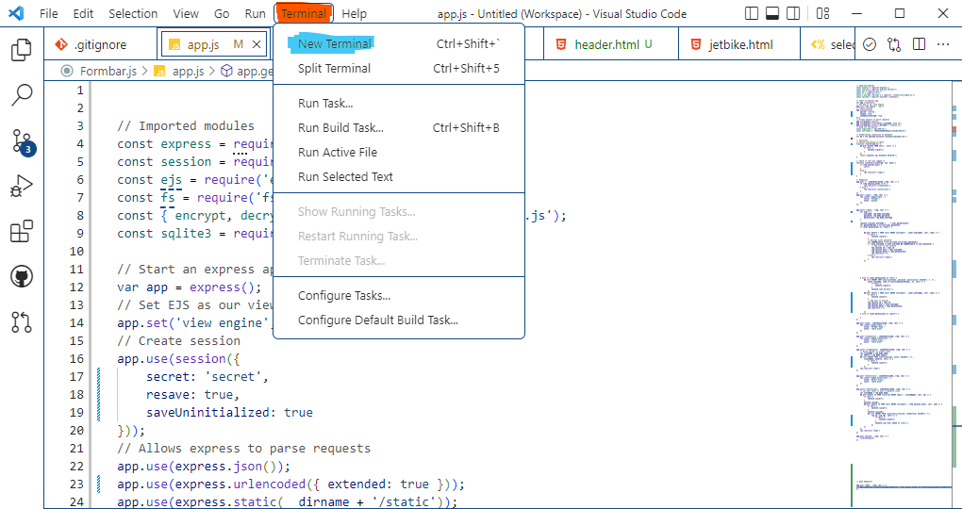

Now that is complete you might have selection box in the top center of the screen that asked which file path you want it to be opened in. Click the file path in which you are currently working in. The terminal usually starts on PowerShell. To switch terminals or add more terminals you will click down arrow next to the + button in the top right of the terminal. The button is highlighted below. Once that is clicked you can select which type of terminal you would like as shown below.

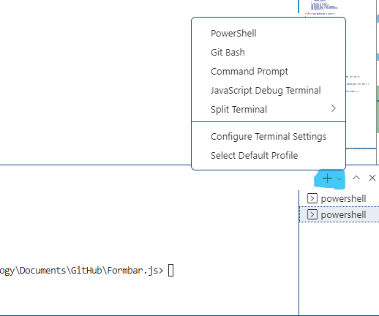

That is the first feature that is built into Visual Studio Code. The next feature or shortcut is the atom beautify feature. This feature is mostly a shortcut to organize your code and use correct format. It will automatically indent your code and make correct spacing for each line. You can either click in the file if you want all of the file to be formatted or highlight certain lines inside of code inside of a file. Once the code is selected you can use the shortcut: Alt+Shift+F.

The third and final built-in feature we will go over is the line movement shortcut. This shortcut can be used to moves line(s) of code up or down without needing to cut/copy and paste it into that spot. With this shortcut you will use the arrows keys to move a line or highlighted line to the desired designation. The shortcut is very useful when using callbacks inside of another callback and needing to test if something is working in and out of them. Also, within if statement and there are many other ways it can be useful. The way to use it is to click Alt+Up arrow or Down arrow (Depending on with direction you would like to shift the line to. Notice that if you don’t highlight the code it will just move the line in which your cursor is currently placed on. You do not need to highlight the line if it is just a single line.

## SQLite VSCode Extension

For this feature we will need to install an extension using the built-in extension installer. On the left side column click the 4 blocks with one disconnected. (Shortcut: Ctrl+Shift+X) Once there click inside the ***Search Extensions in Marketplace*** box. You will type ***SQLite*** inside of it. The first option should be an extension made by a guy by the name of ***alexcvzz***. Click on that and then hit the install button. Wait for the installation to be complete. You might need to restart visual studio code after the completion of the installation. Most of the time you will not need to do that but it doesn’t hurt to do it.

Once installation is complete we can then start getting into the features of SQLite VSCode. The first feature which is one of the biggest features allows you to see and explore your database. In order to access this, you will need to open the ***.db*** file. Using the shortcut: Ctrl+Shift+P you will complete that. That shortcut should bring up a search bar and list of commands you could do. Since you just installed the SQLite extension the ***SQLite: Open Database.*** This will open another search panel where you can select which database you are trying to open. Select the file you wish to open. This will create a tab in the second column at the bottom named ***SQLITE EXPLORER.***

Inside of the dropdown you will be able to open another dropdown menu which has the name of the database inside of. Inside there it will show the table which also how a dropdown to show the fields the table has. You can open as many database files as you want using the same process. It will add another dropdown menu to the column inside of the ***SQLITE EXPLORER*** tab. On right side of the tab ***SQLITE EXPLORER*** you can click the refresh symbol which will reload your databases if they have changed since opening them. To the right side of each table tab you will be able to click the button that looks like a play button. When clicked it will open a new tab in the editor which will show a table. This shows the data values inside of the table.

This new page that has opened shows you all values inside of the table. You will not be able to edit these values inside of here. They can only be changed by the website itself. Though you can not use it to edit it you can in fact get the sqlite3 commands in order to change the values. The top left of the page shows a dropdown button that is named ***SQL.*** This will dropdown a sqlite3 command in which can be used to access the data inside the table. This extension allows you to query through tables without knowing the commands off the top of your head.

One of the last features is the ability to export your table to another file type or language. The three that you are able to easily export to are ***.csv, html,*** and ***.json*** files. This will help speed up the process if you are using the database and want to convert it to another file to view, transfer, or store. To do this you will need to click one of the three buttons in the top right corner. Every button opens a new page to a file that is not currently saved. You will need to save that file and create a name. This isn’t 100% perfect so you might need to fix a few errors if they occur. As of right now it will work most of the time without any errors.

## Quality of Life Extensions

This section will consist of four different extensions that can be added to speed up our production time. They are not necessary or add life changing items. They do however create faster way to complete things. They also add snippets which are repetitive. They will clean up design of VSCode and add autocomplete features.

The first extension is JavaScript (ES6) code snippets. This extension will add snippets that Atom and many other editors have built in. These snippets will speed up the time it takes in order to build applications. The snippets are used to import, export, create classes, loops, and console commands. All of these items are used so often in JavaScript and will greatly impact the speed at which you can add new features to your application. One of the most used things is the ***console.log()*** method. Using the snippit ***log*** you will be able to write things to the terminal quick and easy. This may seem like a very small snippet that barely changes anything. But this will increase your productivity quickly and allow you to makeshift debug your projects with ease. Another useful snippet added by this extension are all the loop methods and class helpers. These all help create loops with no confusion at a fast speed. The class helpers will allow you to create classes at a much quicker pace.

The next extension, ***Auto Close Tag***, will help you in using html inside of your other files. Sometimes you may need to send ***html*** from your ***.js*** file. This extension will give you the html close tags like you would get inside of a ***.html*** file. Overall this extension is great when using node.js to render files.

The third extension is the ***Material Icon Theme***. Now to start off this extension is not necessary at all. This is more of a personal preference. This extension will change the icon each folder and file type uses. I personally use this to tell the different between each file used. It will automatically get the file extension and add the icon to the left of the file name. This will help for organization and making sure each file type is in the current file. Also, if you have many files with the same name and different extensions to the name it will help separate them from each other. This extension is not important yet a great tool in order to organize and differentiate your files.

The final extension goes by the name ***Path Intellisense.*** This extension will autocomplete your filenames or paths. It will allow you to get to your path at a quicker rate do you autocomplete. It searches through the files in that directory and list it as an option to autocomplete you path. This is a great improvement when trying to figure out if you are in the right folder and file. It also is a great help when you don’t have the path already up where you can copy and paste the path location. Instead you just start typing out he path and it will essentially help you get to the file.